Staff Training : Git Task

1. Create blank repo in github / gitlab  
   xxx-example-101
2. Clone repo into folder
3. Create .gitignore file
4. Populate Readme.md
5. Unzip react source   
   <https://facebook.github.io/react/tutorial/tutorial.html>  
   <https://codepen.io/ericnakagawa/share/zip/vXpjwZ/>
6. Commit changes into git
7. Check that you can see code appear on github/gitlab

Staff Training : Grunts Task

1. Create sample package.json gruntfile.js inside git repo (see examples)
2. Install grunt packages   
   ‘babel-preset-react, react, babel-preset-es2015, babelify, grunt, grunt-babel, grunt-browserify, grunt-contrib-watch, http-server’
3. Install ‘grunt’ and ‘grunt-cli’ globally
4. Make Gruntfile.js load grunt-browserify
5. Config grunt-browserify to compile jsx into js
6. Set the default task to run browserify task
7. Test website using http-server grunt task  
   node node_modules/http-server/bin/http-server;  
   <http://localhost:8080>
8. Commit changes into git

Should look like

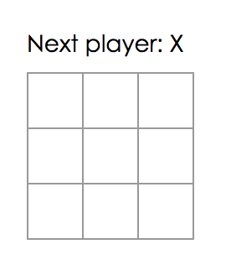

Staff Training: Jenkins Task

1. Create new job in zapper-101 folder [/job/zapper-jenkin-101/](https://jenkins.monitoring.bskyb.com:8082/job/zapper-jenkin-101/)
2. Should be ‘Freestyle project’ and named ‘xxx-test-project’
3. Setup job to pull from the git repo you set up previous
4. Setup job to poll every 5 mins
5. Setup job to install npm and run grunt
6. Setup job to deploy to ‘Dev Web Server ud000224’,   
   directory :  
   dashboards/zapper-jenkin-101/xxx-test-project  
   exec command :  
   chmod -R o+rx xxx/htdocs/dashboards/ zapper-jenkin-101/xxx-test-project
7. Do the same for the other pair server ‘Dev Web Server ud000225’
8. Test it’s deployed correctly   
   xxx/dashboards/zapper-jenkin-101/xxx-test-project/

Staff Training: Javascript Task

Using the git repo

Using the grunt task to test locally

Using Jenkins to check its working remotely

Complete the react practical

<https://facebook.github.io/react/tutorial/tutorial.html>